Name: Rakshitha.M

USN:1RVU22BSC079

**Activity 3:** **Implementing BMI Calculator**

**UI Components:**

* **Edit Text:** for entering weight (in kg) and height (in feet).
* **Button to trigger the BMI calculation.**
* **Text View** :to display the calculated BMI and its corresponding category.

**BMI Calculation:**

* Capture user input for weight and height.
* Convert height from feet to meters (1 foot = 0.3048 meters).
* Calculate the BMI using the formula:

BMI= Weight (kg)

Height (meters)^2

* Display the BMI value along with the respective category .

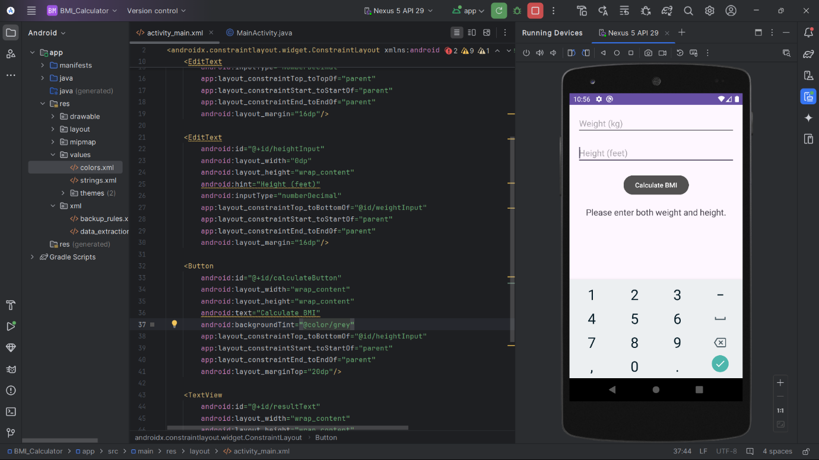

**2. MainActivity.java**

Captures user input, processes the BMI calculation, and displays the result on the screen.

**BMI Categories**:

1. **Underweight**: BMI < 18.5
2. **Healthy**: BMI 18.5 – 24.9
3. **Overweight**: BMI 25 – 29.9
4. **Obese**: BMI 30 – 34.9
5. **Extremely Obese**: BMI ≥ 35

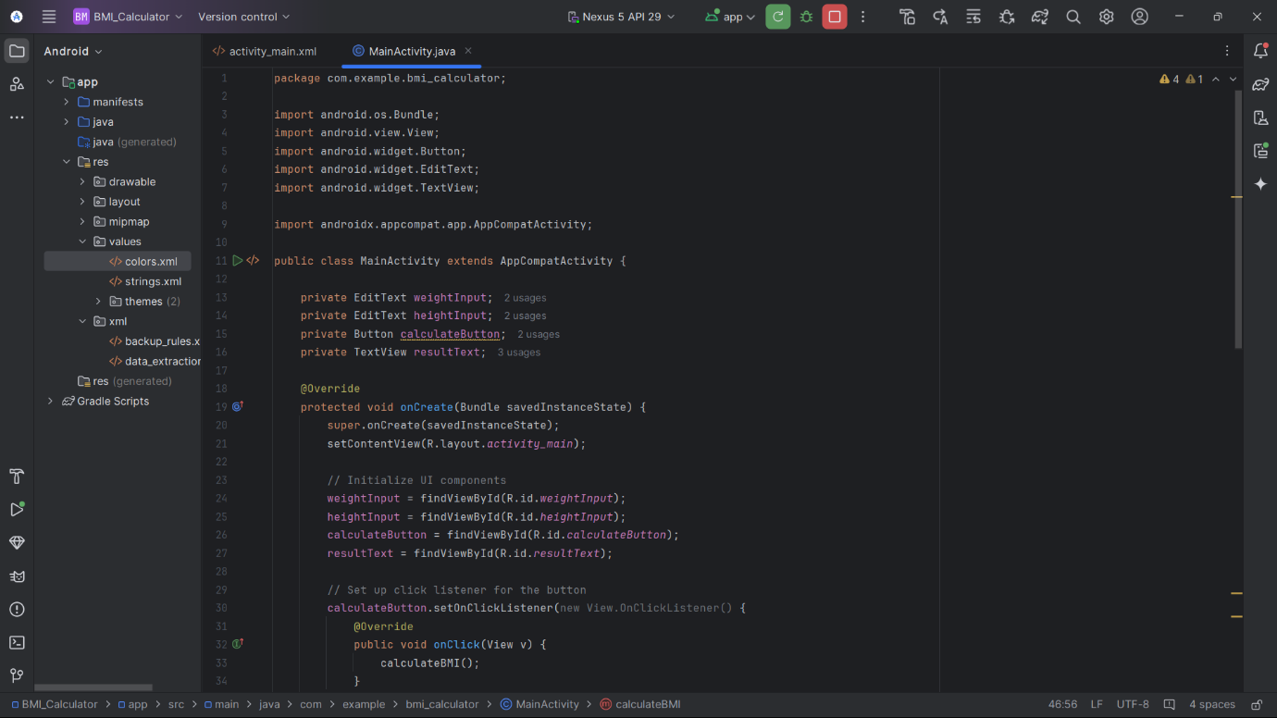

**3. activity_main.xml**

The layout includes:

* **Edit Text** for weight and height input.
* **Button** for triggering the BMI calculation.
* **Text View** to show the resulting BMI and its category.
* 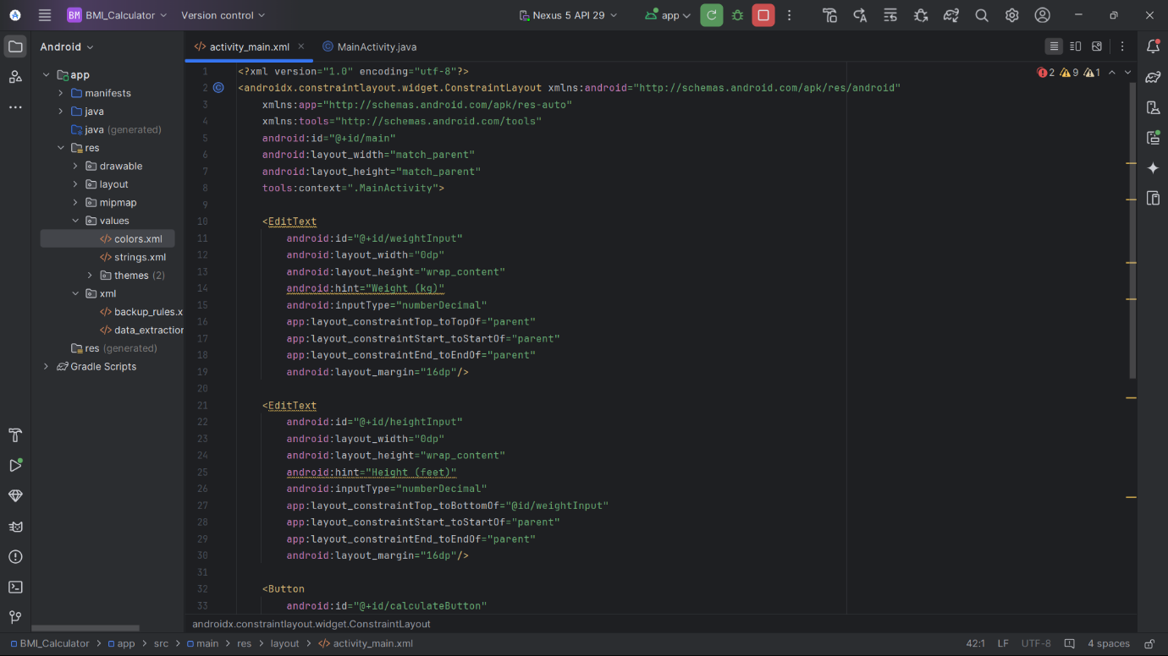

**Output:**



